Billy Espinar

Final Hands-on assessment
Completed Project Documentation

Contents
Fact Sheet 2
Project Information 2
All Servers 2
Server Information 2
Network Diagram 3
ADDS Diagram 4
ADDS Server 4
DHCP Server 5
Organizational Units (OUs) 6
Client Machine 9
File Server 10
Shared Folders 11

Fact Sheet

Project Information
Project Theme: Fallout
Domain Name: Fallout.exe

All Servers
Domain Password: Warneverchanges1997
OS: Windows Server Datacenter

Server Information
***Server Information - Server names must include 25+ Your Initials. e.g., Tron25DrC
- Server #1
  - NetBIOS: CapWaste25BE
  - Role: ADDS, DNS
  - IP Address: 192.20.4.50
  - Subnet Mask: 255.255.0.0
  - No Gateway
  - DNS: 192.20.4.50
- Server #2
  - NetBIOS: Mojave25BE
  - Role: ADDS, DHCP
  - IP Address: 192.20.4.53
  - Subnet Mask: 255.255.0.0
  - No Gateway
  - DNS: 192.20.4.50
- Server #3
  - NetBIOS: CWealth25BE
  - Role: FSRM
  - IP Address: 192.20.4.55
  - Subnet Mask: 255.255.0.0
  - No Gateway
  - DNS: 192.20.4.50

Network Diagram
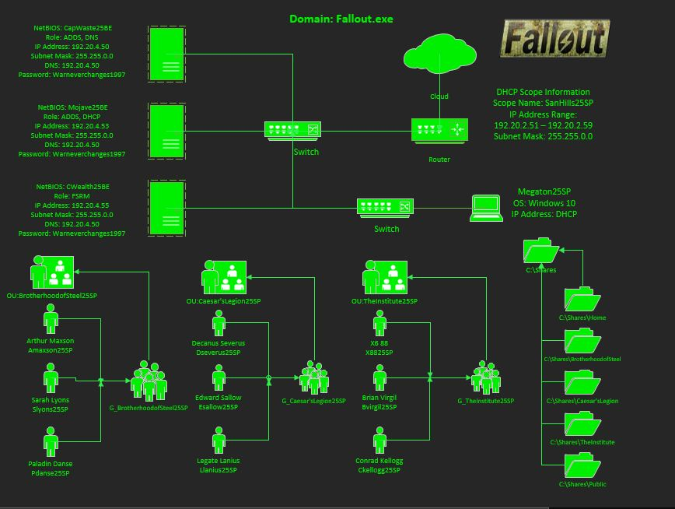
Figure 1: Network Diagram

ADDS Diagram
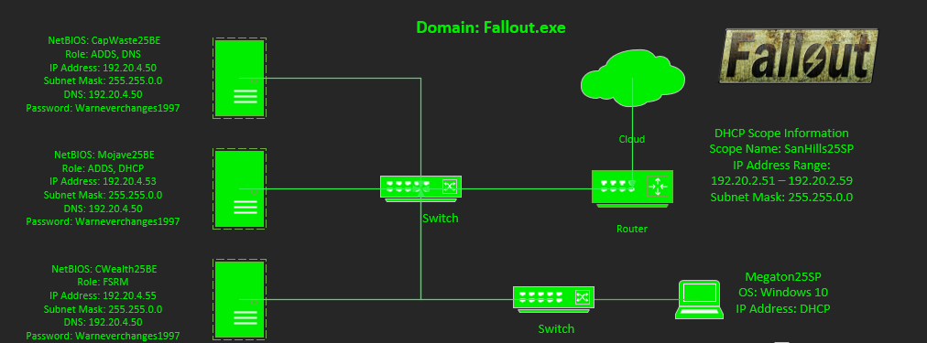
Figure 2: Adds Diagram

ADDS Server
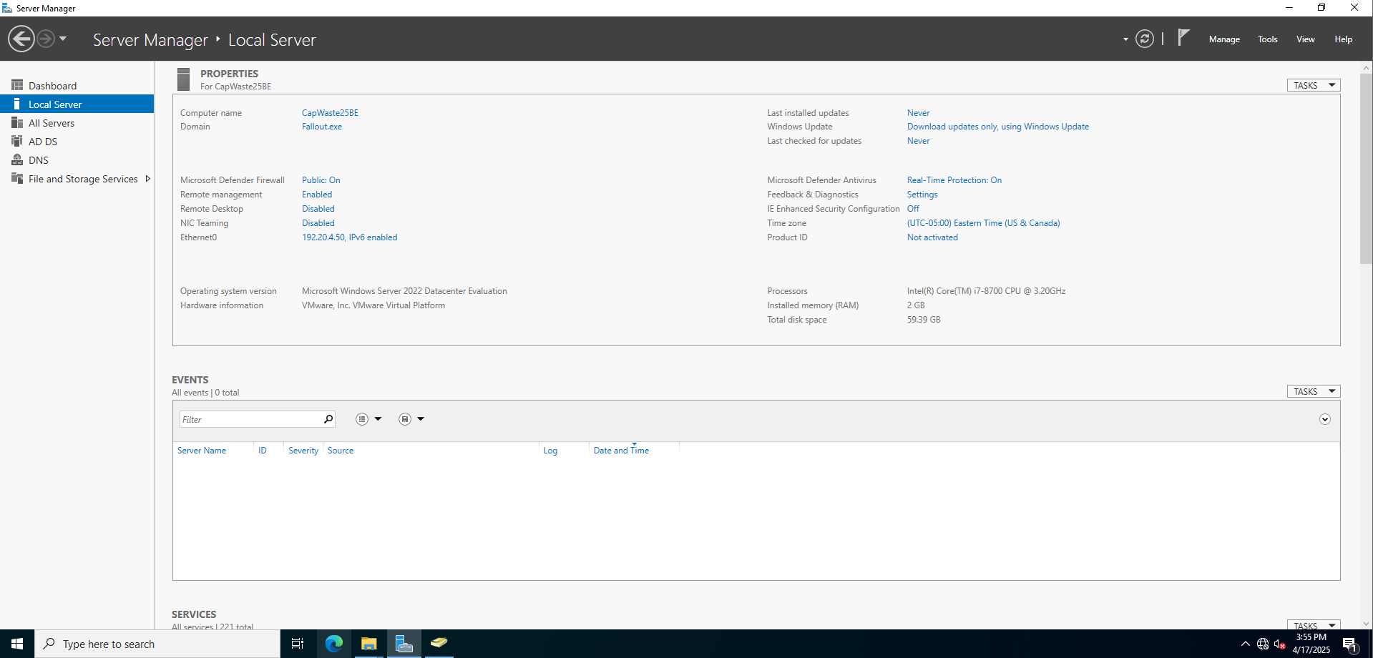
Figure 3: Local Server information

DHCP Server
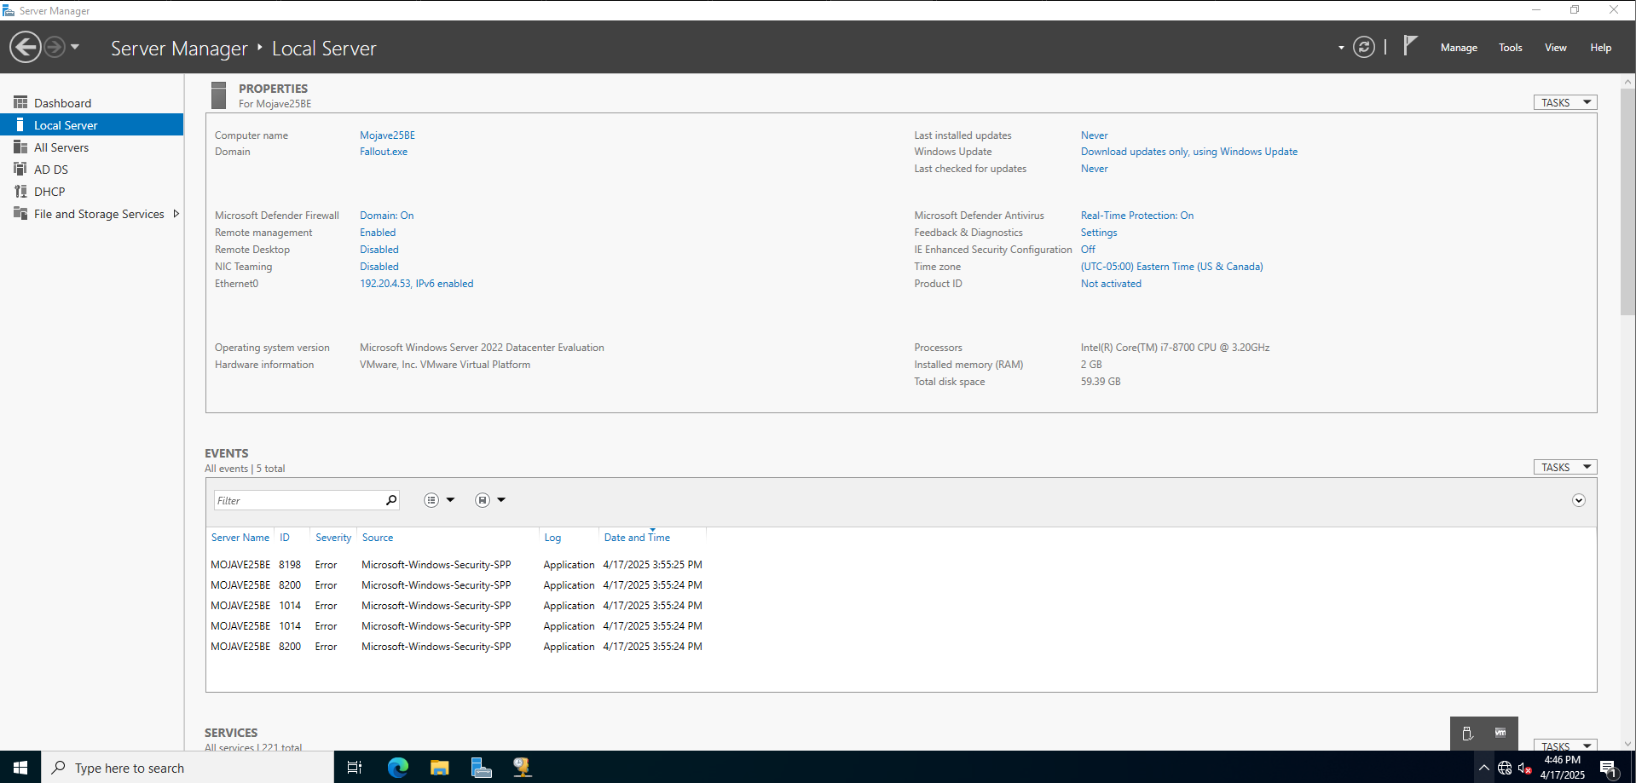
Figure 4: Local Server screen

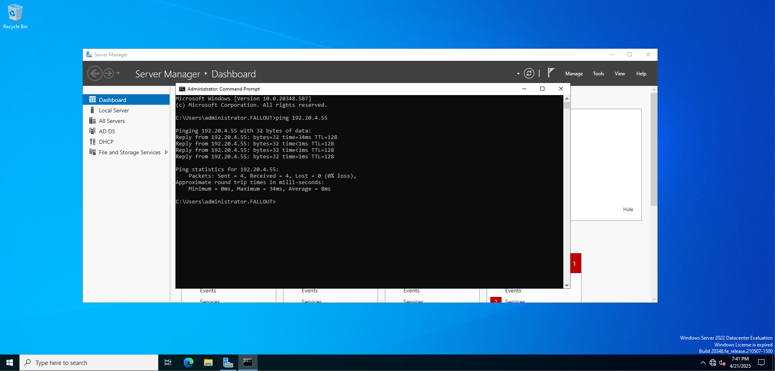
Figure 5: Ping
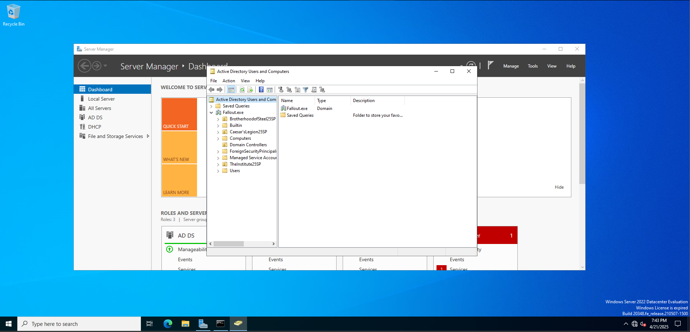Figure 6:DC in the Active Directory Computers and Users

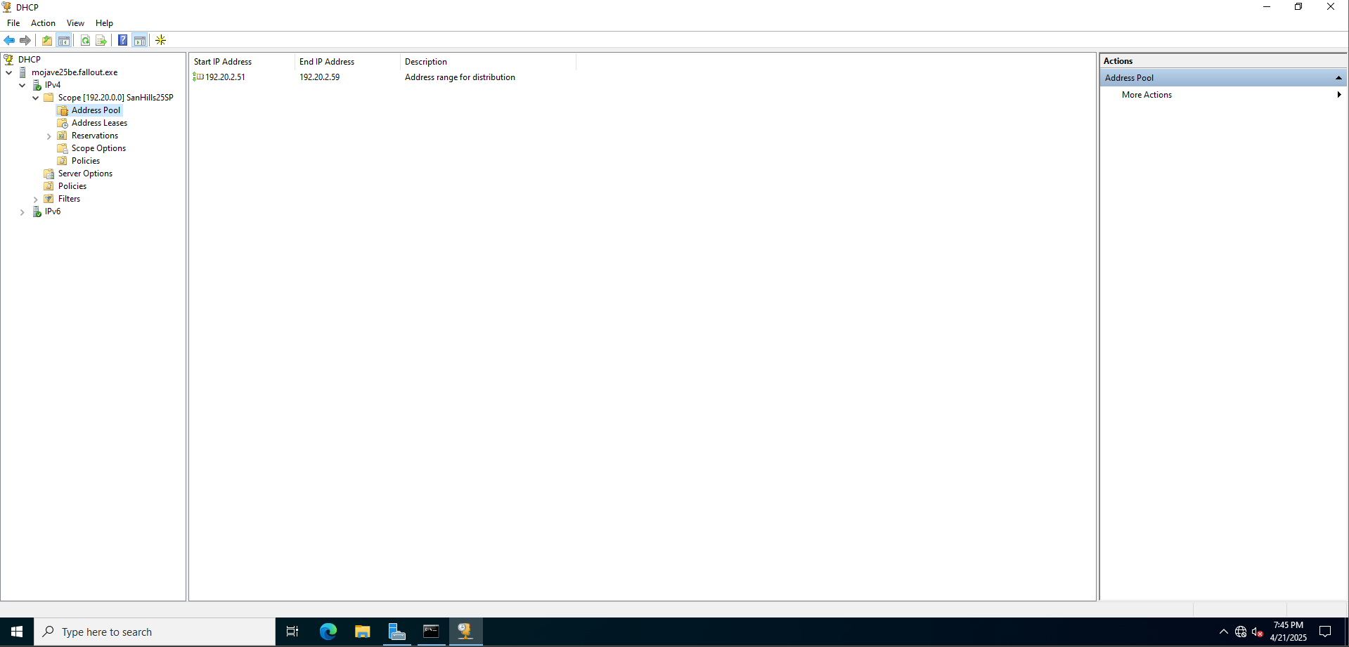
Figure 7: DHCP Scope Range

Organizational Units (OUs)
- OU #1
  - Name: BrotherhoodofSteel25SP
  - Group Name: G_ BrotherhoodofSteel25SP
  - User #1: Arthur Maxson/Amaxson25SP
  - User #2: Sarah Lyons/Slyons25SP
  - User #3: Paladin Danse/Pdanse25SP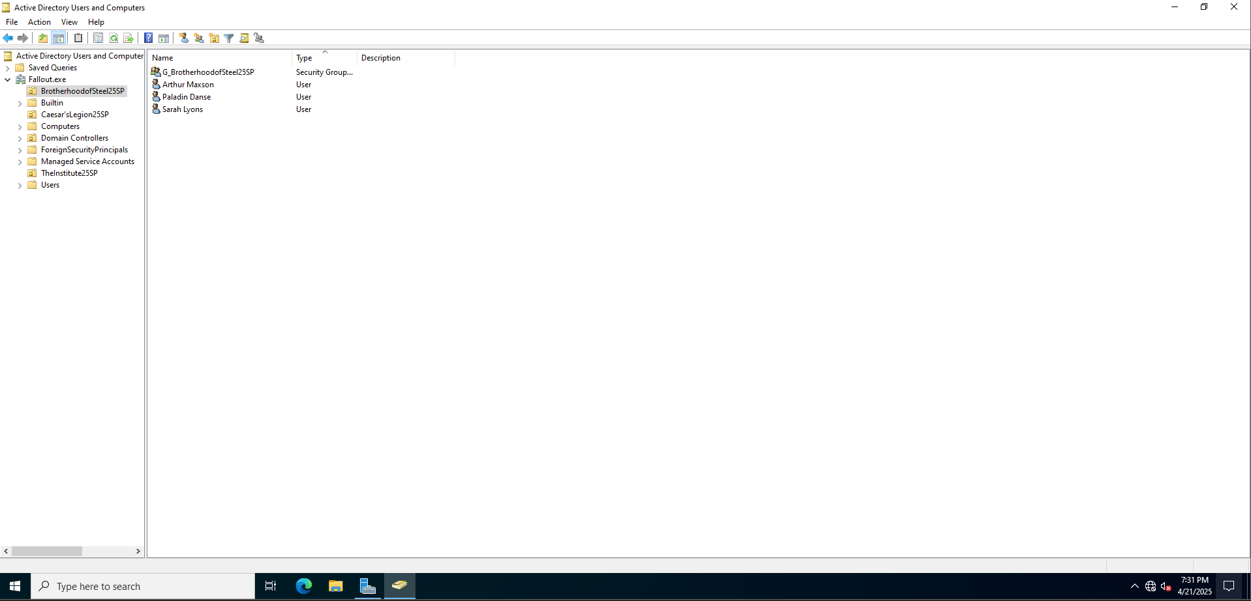
Figure 8: OU #1

- OU #2
  - Name: Caesar’sLegion25SP
  - Group Name: G_Caesar’sLegion25SP
  - User #1: Decanus Serverus/Dseverus25SP
  - User #2: Edward Sallow/Esallow25SP
  - User #3: Legate Lanius/Llanius25SP
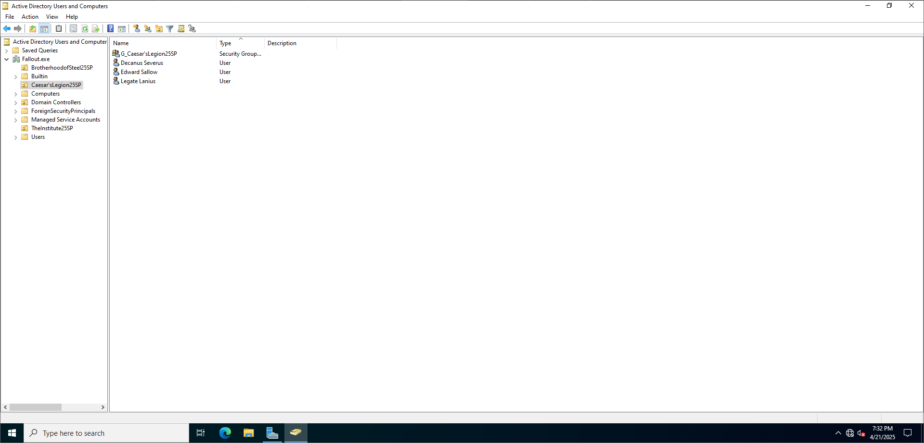
Figure 9: OU #2

- OU #3
  - Name: Theinstitue25SP
  - Group Name: G_ Theinstitue25SP
  - User #1: X6 88/X8825SP
  - User #2: Brian Virgil/Bvirgil
  - User #3: Conrad Kellogg/Ckellogg
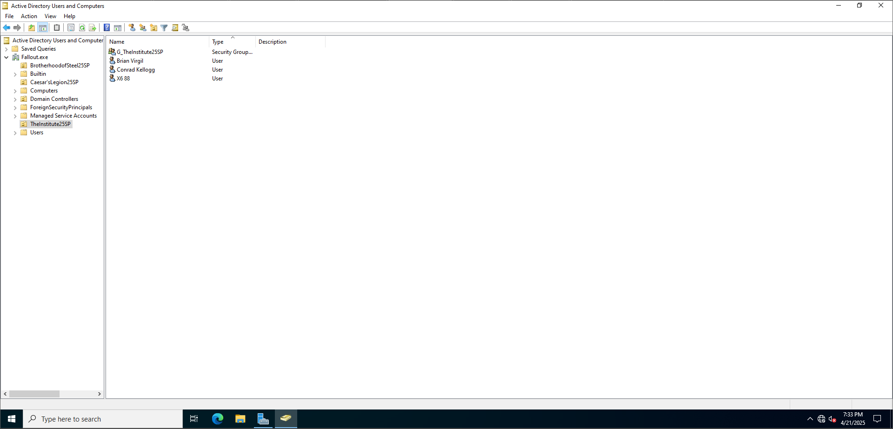
Figure 10: OU #3

Client Machine
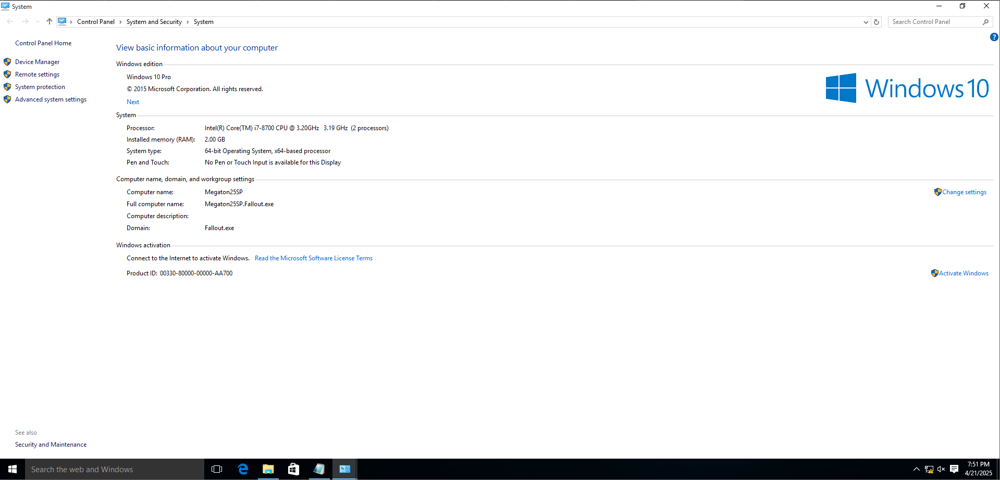
Figure 11:Windows 10 VM

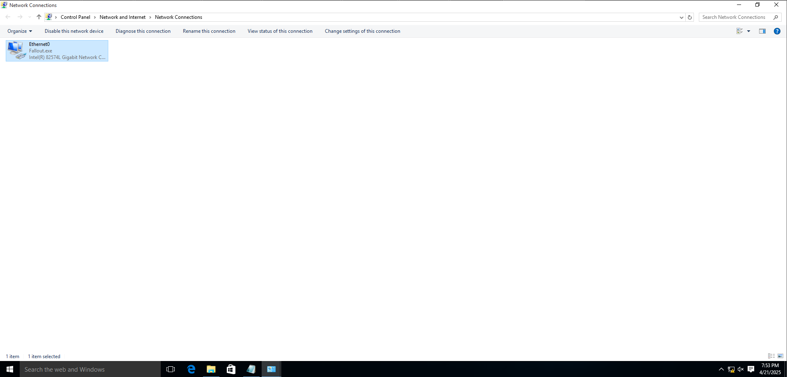
Figure 12: Joined network using DHCP

File Server
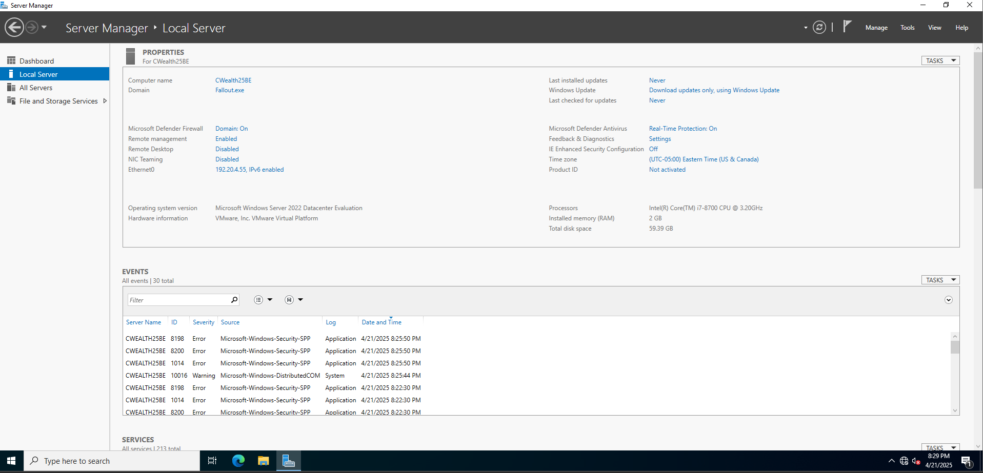
Figure 13: File Server

Shared Folders
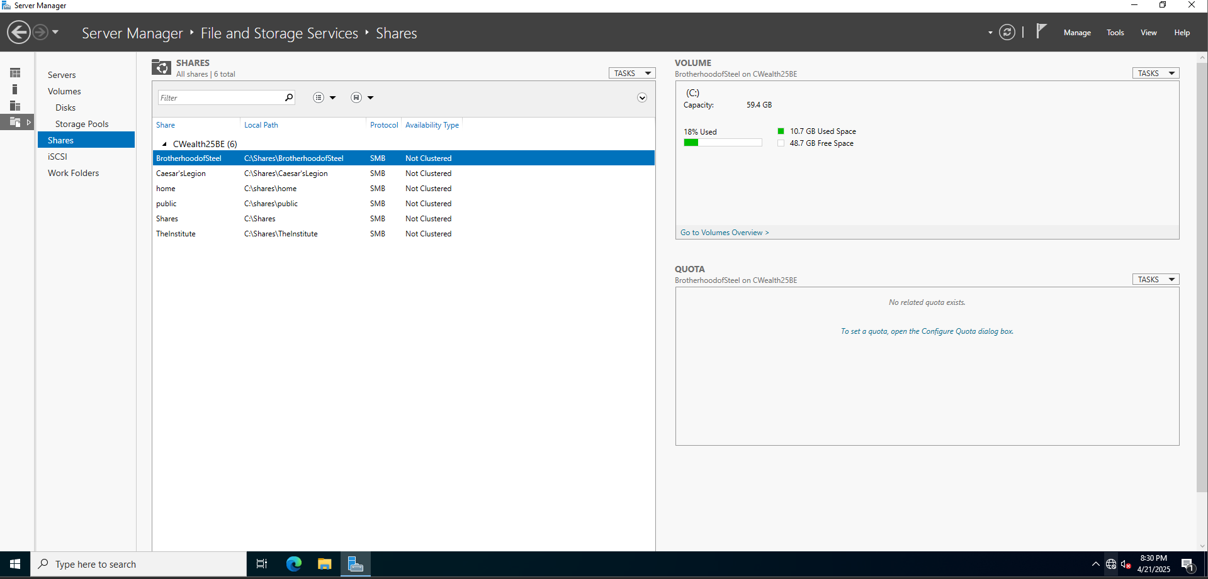
Figure 14: Shared Folders

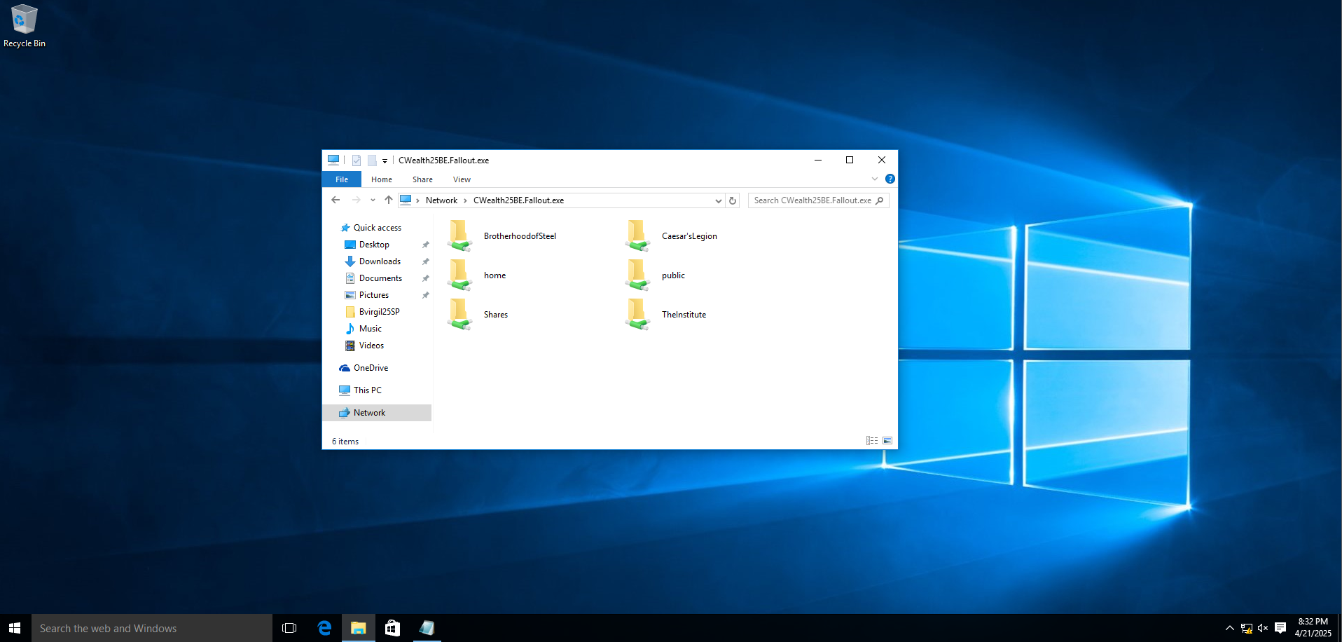
Figure 15: Client Server

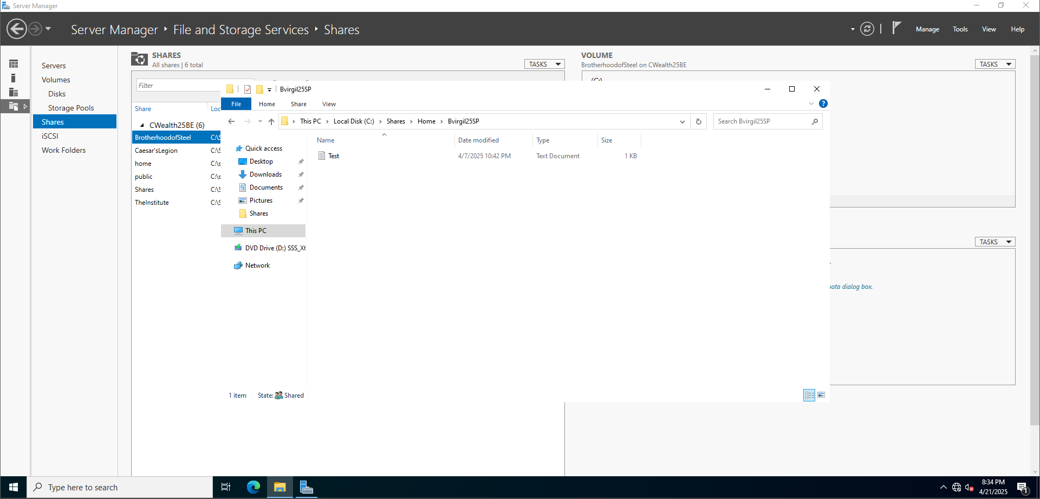
Figure 16: Path and Drive

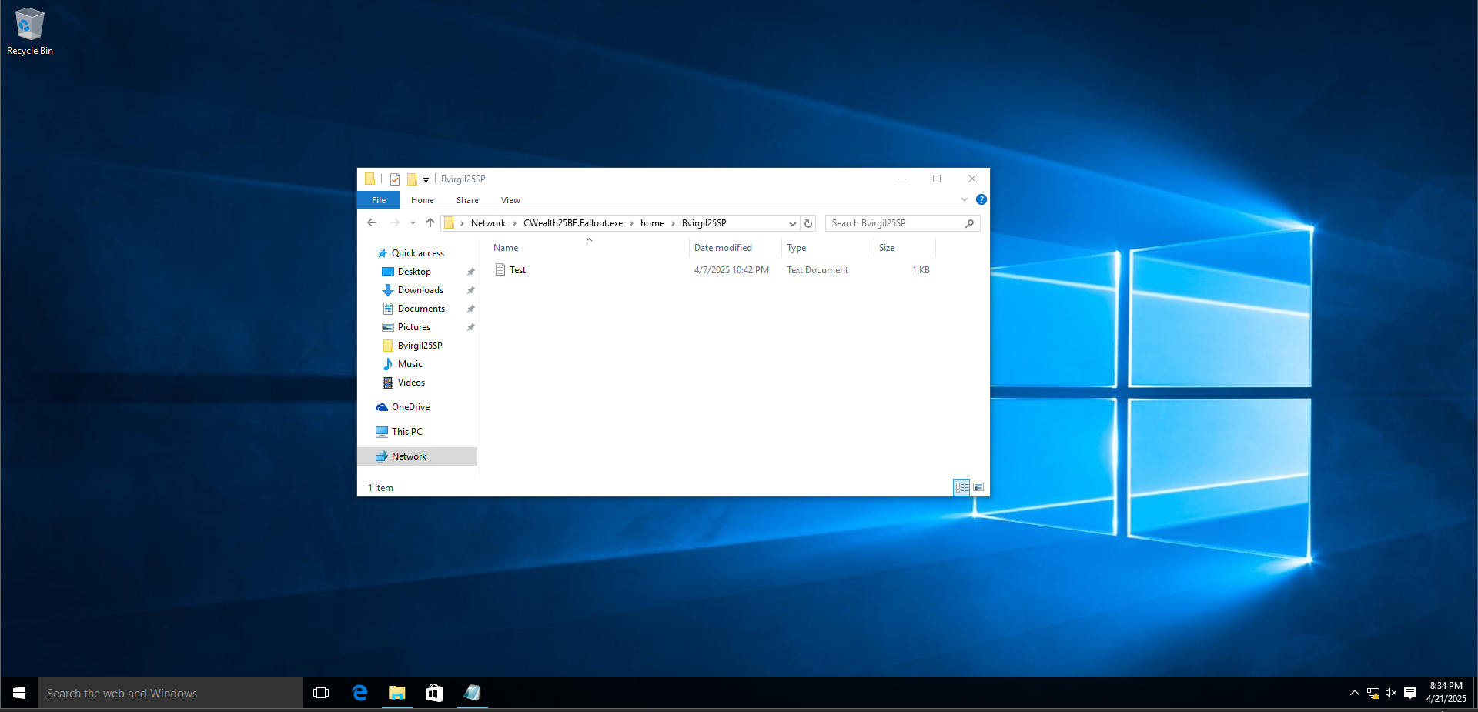
Figure 17: Test file

